2016 Fall Review - Name_______KEY_________________

Chapter 1 - Scientific Investigations

Define / describe:
Independent variable (manipulated variable) – the factor that you want to test. It is changed by the investigator to observe how it affects the dependent variable
Dependent variable (responding variable) – the factor that a scientist observes or measures during an experiment
Scientific Process – the process scientists use to investigate and explore natural events and gain new information that results from those investigations (Problem, Hypothesis, Procedure, Results, Conclusion)
Lab Safety – always follow the teacher’s instructions, use proper safety equipment, only conduct the experiment your teacher has instructed you to, inform the teacher of any accidents immediately

Complete the table below:

PROPERTY OF MATTER | definition | Instrument(s) used to measure | units
mass | amount of matter | triple beam balance | grams
volume | amount of space matter occupies | graduated cylinder | mL
density | the amount of mass in a specified space | mass / volume | g/cm³

Chapter 2 - Interactions of Matter & Energy

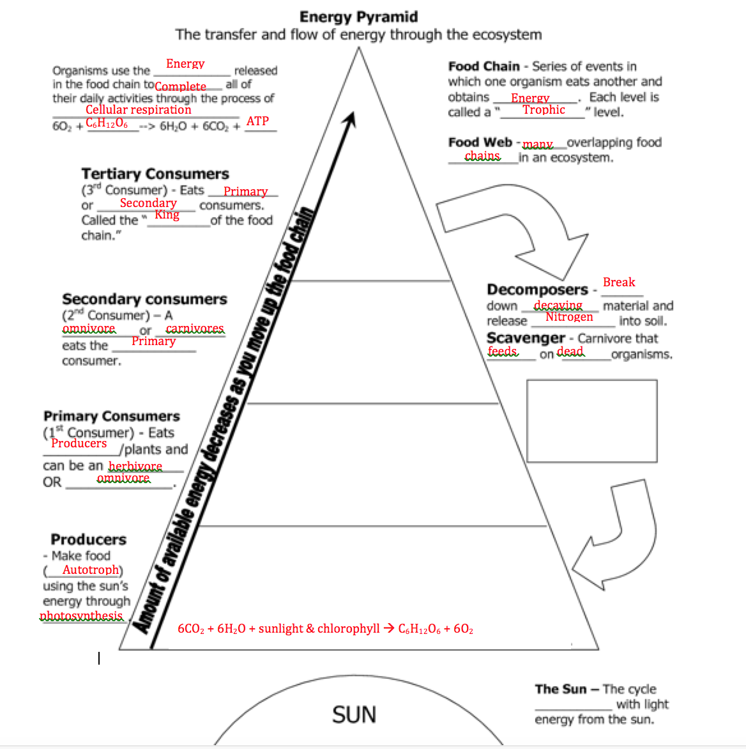

The function of bacteria:fix nitrogen to make it usable for plants

The site of Cellular Respiration: cytoplasm and the mitochondria

The site of Photosynthesis: Chloroplast

Cellular Respiration
C₆H₁₂O₆ + 6O₂ → 6CO₂ + 6H₂O + Usable Energy

Glucose + Oxygen → Carbon Dioxide + Water + ATP

Photosynthesis
6CO₂ + 6H₂O → C₆H₁₂O₆ + 6O₂
Carbon Dioxide + WAter → Glucose + Oxygen
Sunlight

Chapter 3 - Carbon Chemistry

Define Organic Compound: a compound that has carbon bonded with at least one hydrogen

Know the following Biological Molecules and give examples
- Proteins
Made of amino acids
Our body is made up of them… hair, skin, nails, and muscles
We also get proteins from our foods

- Carbohydrates
A group of organic molecules that includes sugars, starches, and cellulose
Provides a source of energy for our cells

- Lipids
Saturated and unsaturated
A type of biological molecule that includes fats, oil, hormones, waxes, and components of the cellular membrane

Define:
Isomer: one of two or more compounds that have the same molecular formula but different structural arrangement.

Polymer: a molecule made up of many of the same small organic molecules, forming a long chain

Monomer: one of the small organic molecules that make up the long chain of a polymer

Hydrocarbon: a compound that contains only carbon and hydrogen atoms

Chapter 4 - Forces, Energy, & Work

Define:
Force- a push or pull

Mass- the amount of matter in an object

Acceleration-the measure of the change in velocity during a period of time (speed up, slow down, or change direction)

Weight- the amount of force the acceleration of gravity exerts on an object

How does increasing the force affect the acceleration of an object?
Increases acceleration

How does increasing the mass affect the acceleration of an object?
Decreases acceleration

Formula for finding the Force of an object:

Force = Mass X Acceleration

Formula for finding the Work produced:

Work= Force X Distance
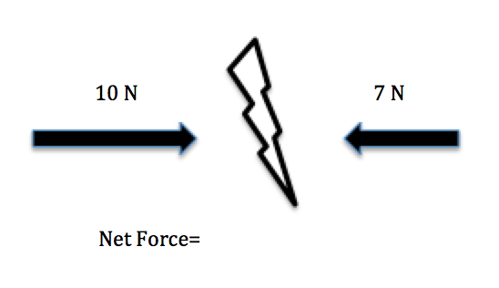

Name the units:
Force: Newtons (N)
Work:Joules (J)
Energy: Watts (W)

How much work is used to move a 15 kg box a distance of 15 meters?
W=FxD
F=15x15
F=225 Joules
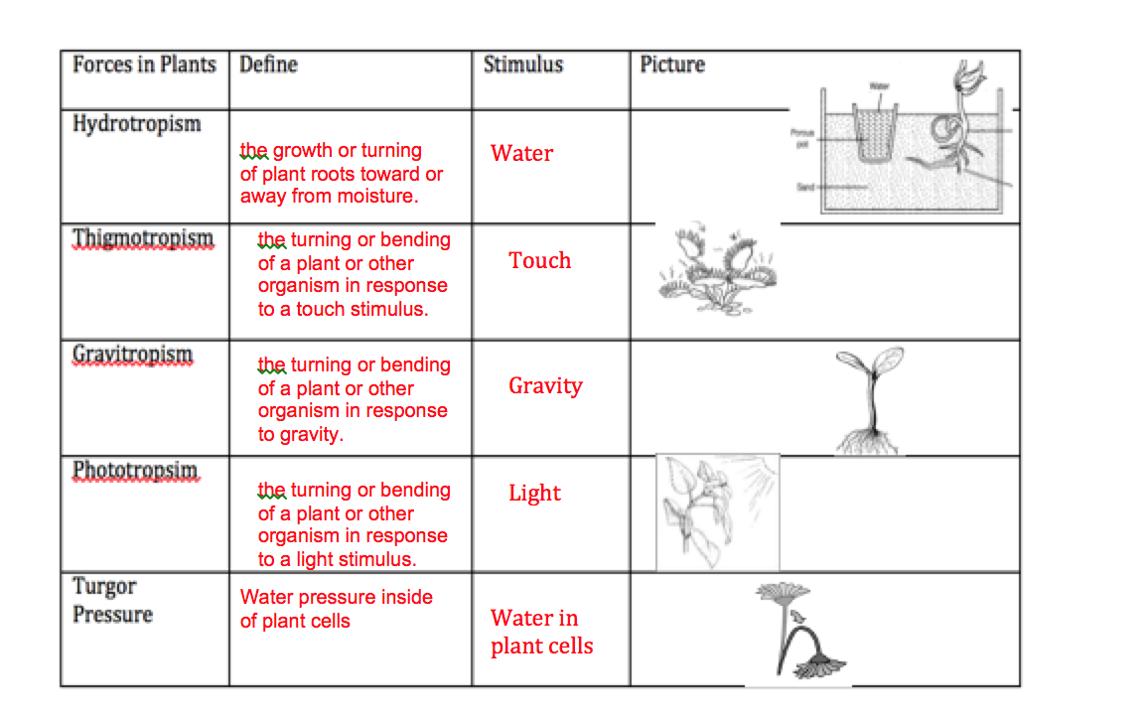

Chapter 5 - Weather and it’s Impacts
Define:
Weathering- the breaking down of rock by physical (mechanical) or chemical means

Erosion- the movement of sediment from one place to another

Deposition- the laying down of sediment in a new location

Explain how erosion and deposition affect waterways such as rivers and streams.
Waterways such as rivers and streams can be changed physically because of erosion and deposition. The force of the water can erode sediments away changing the shape of the river or stream possibly causing a meander or oxbow lake to form. When existing sediments are carried away to a new place, they will be deposited at the lowest point creating things such as deltas and alluvial fans.

The force that causes all mass movements is _gravity____.
What kind of weather do we experience in a high pressure?
Fair, sunny, nice weather with light winds.
What kind of weather do we experience in a low pressure?
Strong storms and high winds, hurricanes and tornadoes can stem from low pressure systems.
Name an effect on the ecosystem of each of the following Catastrophic Events:

Flood- these can destroy crops, wash away homes, ruin the habitats of animals, cause water pollution, etc.
Hurricane- brings heavy winds and can cause flooding. Winds can destroy homes and habitats and crops.
Wildfire- burns trees and crops, ruining homes of animals and destroying food sources. Destroys homes also.
Tornado- heavy high winds cause erosion and damage to land, crops, trees, buildings. Flying debris destroys.

Chapter 6 - Impacts on Water Systems

Sketch and label a model of an aquifer.
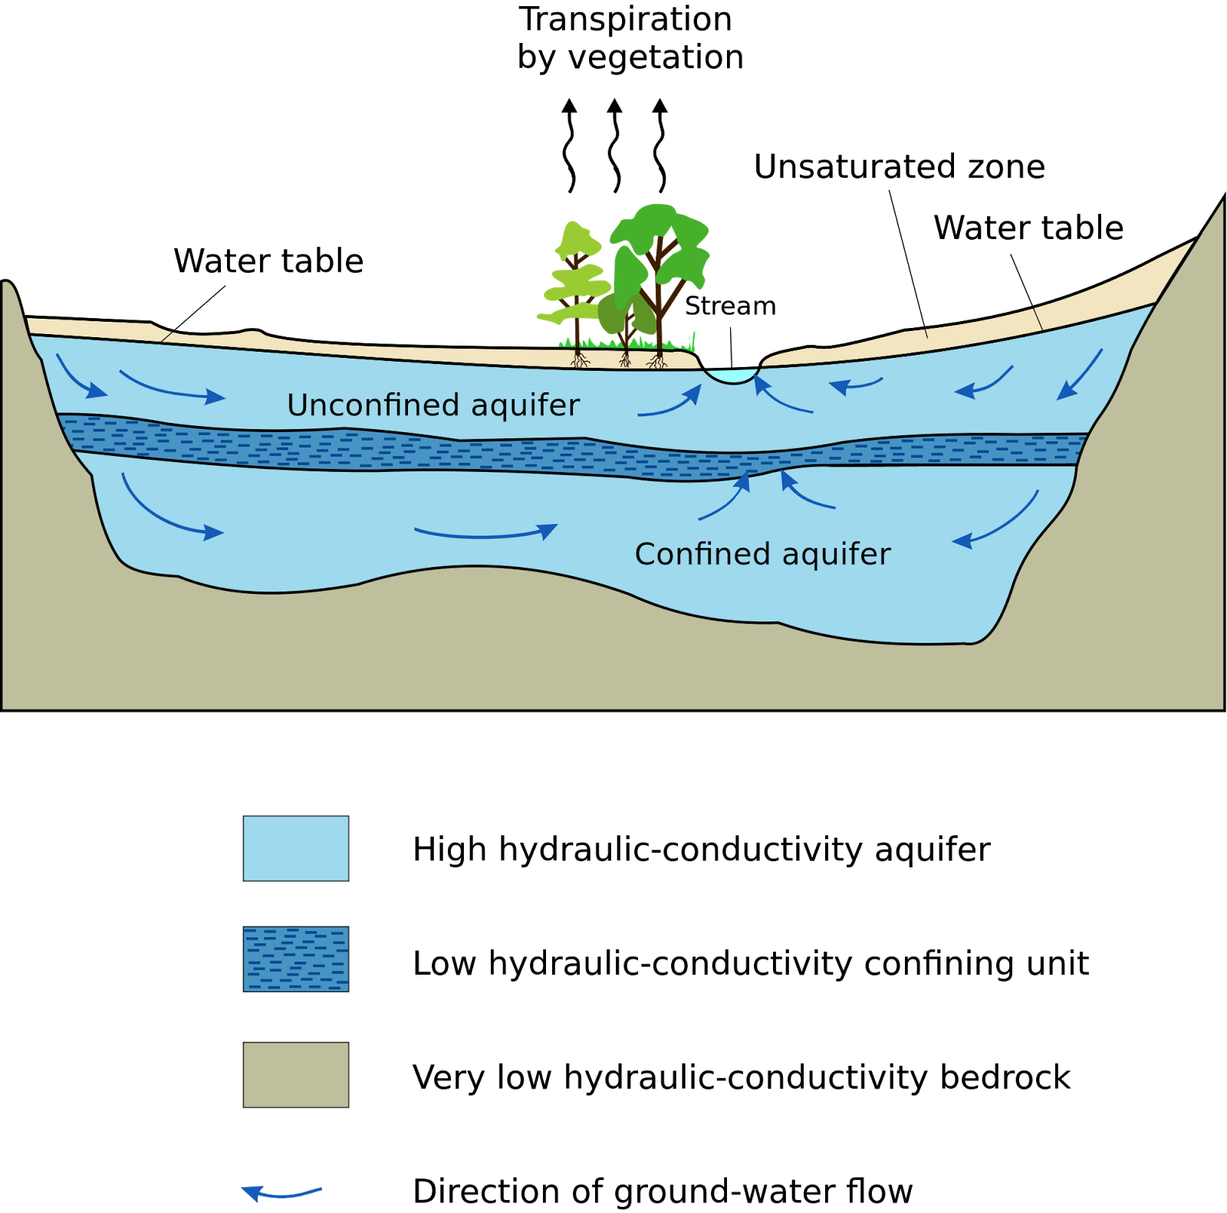

Define:
watershed - an area of land that separates waters flowing to different rivers, basins, and seas.

Describe a wetland. are areas where water covers the soil, all year or for periods of time during the year

What are some functions of a wetland? Values of wetlands include: water quality, water supply, flood control, erosion control, wildlife support , recreation, culture, and commercial benefits

What are some examples of wetlands? Bogs (contain peat), Marshes (grasses), and Swamps (near trees).

Describe the relationship between atmospheric carbon dioxide and global temperatures.
Global warming is primarily a problem of too much carbon dioxide in the atmosphere. This carbon overload is caused mainly when we burn fossil fuels like coal, oil and gas or cut down and burn forests.

Name factors that would raise or lower a water table.
Flooding would cause a rise in the water table while being in a drought or using up too much water from wells would lower the water table.

Describe aquifers with regard to permeability and porosity.
The porosity of a given aquifer is the amount of empty or void space within the rocks or sediments. Permeability determines how easily the groundwater can pass through the spaces in between rocks in the aquifer.

List the major pollutants of streams and lakes.
Fertilizers and pesticides are two major sources of pollution. In many farms, chemicals are sprayed on crops to help them grow and to prevent bugs. When it rains, the extra fertilizers and pesticides flow into streams. Algae blooms and oil on roads also leads to water pollution.

Compare and contrast the effects of glaciers melting versus sea ice melting.
Since glaciers form on land from freezing freshwater, if they melted this would cause the sea level in that area to rise tremendously. And since sea ice is formed in water with the existing sea water, when it melts, the level of the sea will not rise or fall because there’s no additional water that’s melted.

Chapter 7 - Exploring the Solar System

Describe some of the negative physical effects of extended stay in space and what astronauts do to counter them. Astronauts that spend a lot of time in space can suffer from bone and muscle loss due to lack of use. To prevent this loss of muscle and bone, astronauts exercise while in space on treadmills and weight machines.

What type of chemical compounds do scientists look for when trying to identify whether life exists extraterrestrially? Oxygen, nitrogen, carbon dioxide, hydrogen, sulphur, phosphorus, water, etc.

In this solar system, which planet besides Earth is most likely to have liquid water? Why?
Scientists' consensus is that a layer of liquid water exists beneath Europa's (moon of Jupiter) surface, and that heat from tidal flexing allows the subsurface ocean to remain liquid.
Define:

Orbit - the curved path of a celestial object or spacecraft around a star, planet, or moon

Mir - a space station that operated in low Earth orbit from 1986 to 2001, run by the Soviet Union and later by Russia

Skylab - the United States' first space station, orbiting Earth from 1973 to 1979, when it fell back to Earth amid huge worldwide media attention. Launched and operated by NASA, Skylab included a workshop, a solar observatory, and other systems necessary for crew survival and scientific experiments.

Soyuz - a series of spacecrafts designed for the Soviet space program in the 1960s that remains in service today.

International Space Station - is a space station, or a habitable artificial satellite, in low Earth orbit. Its first component launched into orbit in 1998, and the ISS is now the largest artificial body in orbit and can often be seen with the naked eye from Earth. ISS components have been launched by Russian Proton and Soyuz rockets, and American Space Shuttles. The ISS serves as a microgravity and space environment research laboratory in which crew members conduct experiments in biology, human biology, physics, astronomy, meteorology, and other fields.

What was the name of the first artificial satellite put into space? Who put it there?
History changed on October 4, 1957, when the Soviet Union successfully launched Sputnik I. The world's first artificial satellite was about the size of a beach ball and weighed only 183.9 pounds, and took about 98 minutes to orbit the Earth on its elliptical path.

What are some of the advantages of the space shuttle vs the Apollo-like rocket launches?
Single-use spacecraft depend on rockets to lift them off the Earth, The craft's crews sit in the re-entry capsule that is the only part of the vehicle that returns to Earth. The orbiting module stays in outer space while the booster module is abandoned and burns up (in the atmosphere). In contrast, the US-developed space shuttles are reusable space transport vehicles. The shuttles are launched vertically like a rocket, orbit like a satellite, and land just like an airplane. The shuttles are generally considered to provide the best prospect of lower-cost access to space. The reusable launch vehicle is capable of launching more than one payload into space and can transport more cargo than a single-use craft. Each shuttle's cargo bay is designed to have a lifetime of 100 space missions, carrying up to 20 tons at a time. Shuttles also have the advantage of being able to carry satellites to space as well as send up crews to repair them in orbit or return them to the Earth for refurbishment and re-use.

Describe the extent of human space travel.
In April 1970, the crew of NASA's Apollo 13 mission swung around the far side of the moon putting them 248,655 miles away from Earth. It's the farthest our species has ever been from our home planet. Right now, NASA’s nuclear-powered spacecraft Voyager 1 is careening through dense solar winds on its way into interstellar space. It could take months, if not years, but eventually (barring any unfortunate turns) Voyager 1 will become the first human spacecraft to successfully leave our solar system. As it stands, the Voyager 1 spacecraft represents the farthest we have traveled in space: nearly 18 billion kilometers from Earth.

Describe the functions of Earth’s atmosphere.
Our atmosphere filters out deadly radiation from the sun. It also even outs the temperature of the planet cooling down the side facing the sun and warming up the side facing away from the sun so days are cooler and nights warmer than they would otherwise be. And our atmosphere protects the Earth from meteorites, asteroids, and solar winds.

Describe the conditions required for the existence of life. What is its nursery book nickname? Why do you think this nickname is appropriate?
“The Goldilocks Conditions” describe Earth because Earth is perfect for life in every way. Just like Goldilocks wanted the perfect bowl of porridge (not too hot, not too cold), we are in the perfect proximity from the sun. We have water to use, an atmosphere to protect us and keep gasses in, gravity keeps us grounded and stable, our tilted axis and rotation gives us our climates, seasons, and length of days, and the sun again provides light and heat for us which helps plants grow and warms us up.

